A picture containing clipart

Description generated with very high confidence

Azure 103 Module 4

Hands On - 11

Azure Certification Training

[**support@intellipaat.com**](mailto:support@intellipaat.com)

**+91-7022374614**

**US: 1-800-216-8930(Toll Free)**

**Azure 103 Module 4 , Hands On – 11**

**Add RecodSet to DNS.**

**Step 1:** Open the DNS Zone and copy Name Server Addresses.

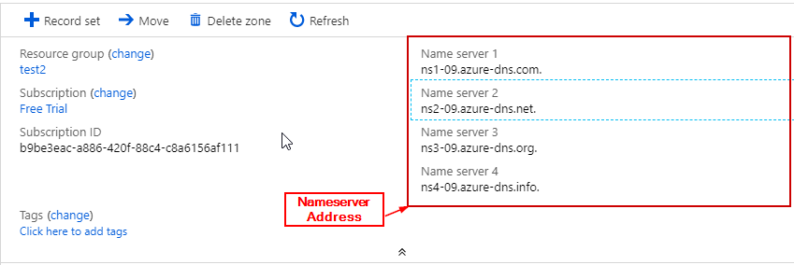

**Step 2:** Change the name server addresses in your domain name provider website.

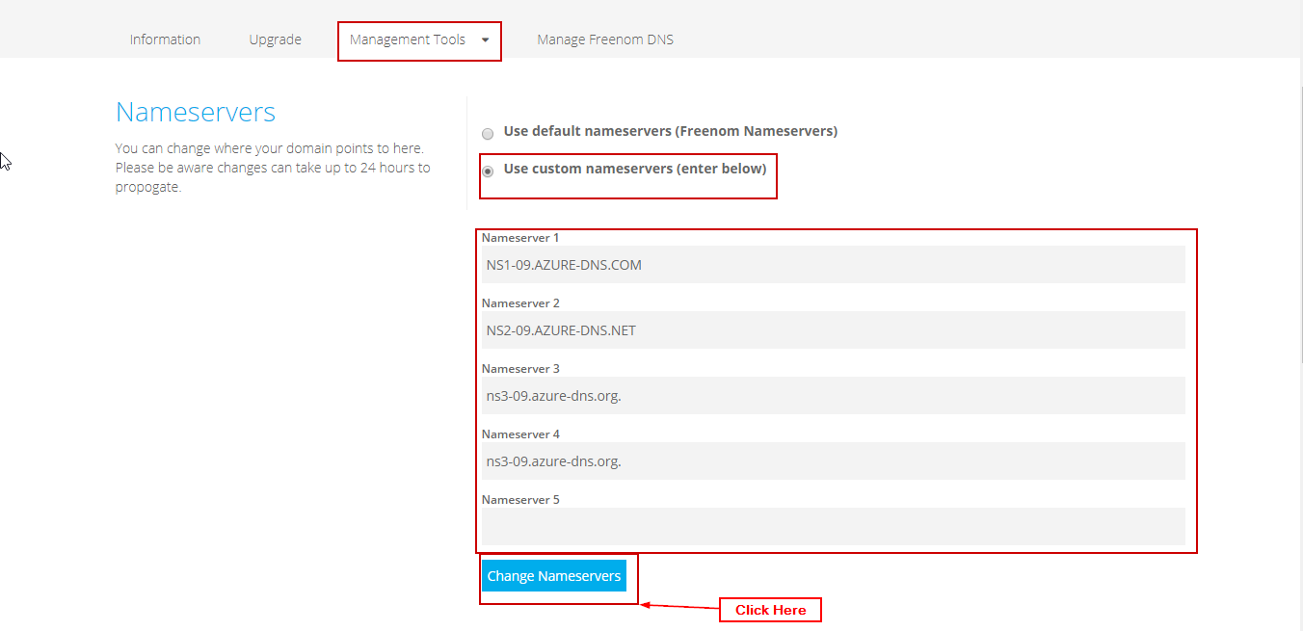

**Step 3:** Open the DNS Zone and click on ‘+ Record Set’.

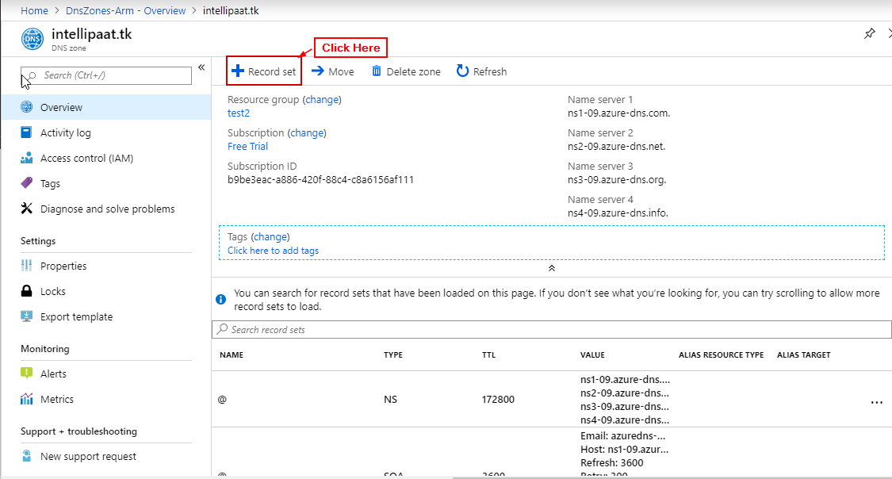

**Step 4:** Enter details and click on ‘OK’ 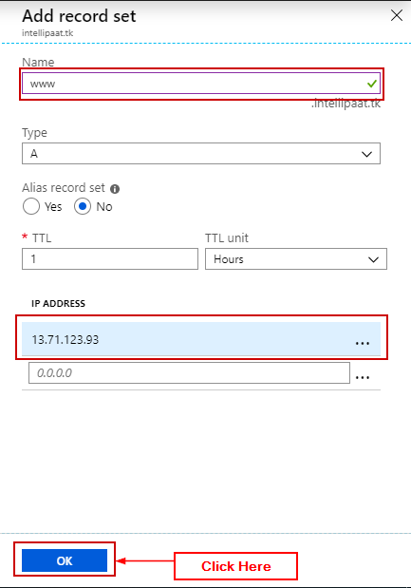

**Step 5:** Now open the domain:

